

**PROJECT REPORTING**

**COURSE NAME: .NET AND C#**

**PROJECT NAME: Faculty Management**

Instructor: Mai Thanh Tuấn

Group 6 member:

Võ Huy Thông – SE61933

Nông Nguyễn Gia Hiển – SE62506

Nguyễn Duy Khoa – SE62678

# Overview

* Purpose: Application management faculty information on winform by C#
* Database: QLSVien

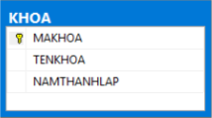

* GUI and functions:

a) GUI: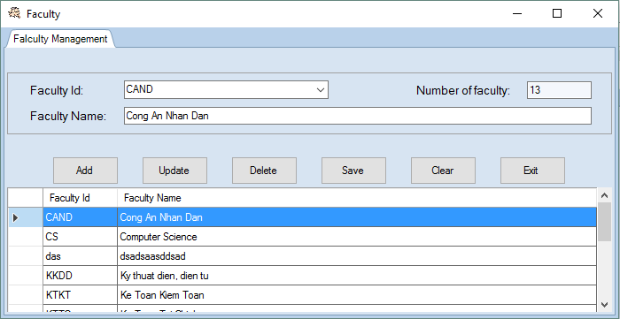

b) Functions:

* Faculties information be loaded from database.
* User select “Faculty Id” from combo box to show faculty information.
* Show total faculties in textbox.
* Gridview show “Faculty Id” and “Faculty Name”.
* Bellow buttons with functions:
* Add: Addding temporarily a new faculty with data are “Faculty Id” and “Faculty Name”.
* Edit: Updating temporarily an existed faculty based on “Faculty Id”.
* Delete: Removing temporarily an existed faculty based on “Faculty Id”.
* Save: Save all change from the starting of application or last save.
* Clear: Clear text input fields(Faculty id, Faculty name).
* Exit: Exit the application. If changing are not save, the message box will show and ask the user to confirm the save.

# Source code

* 1. DBUtils.cs

Connection function: Create SQL connection to QLSVien database to be reused by other functions.

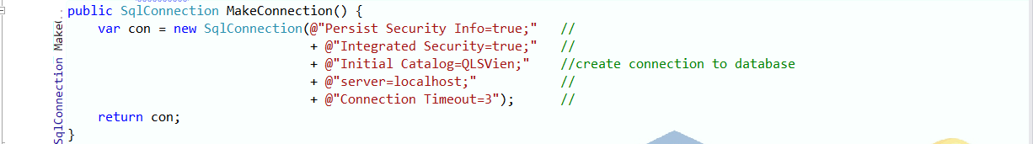

* 1. FacultyDao.cs

2.2.1 Get all data function: Receive every single row of the “KHOA” table in database and add to list.

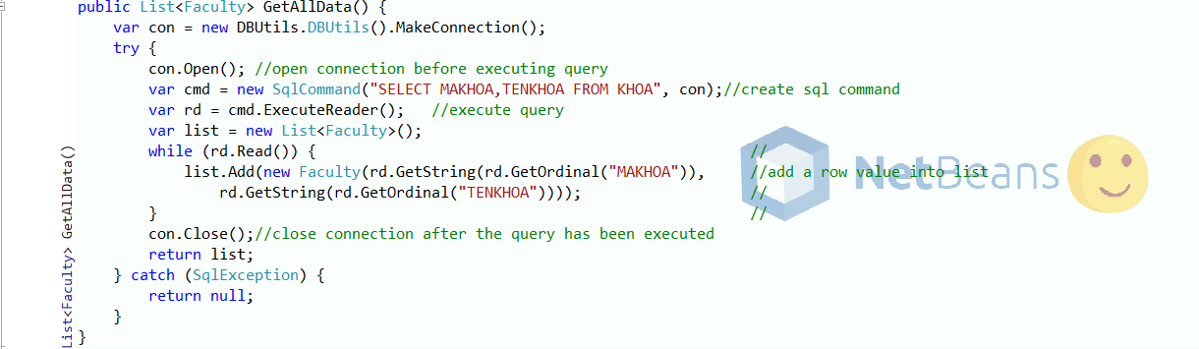

2.2.2 Insert edit delete function: Execute prepared list of queries to add, update or delete a row in the “KHOA” table.

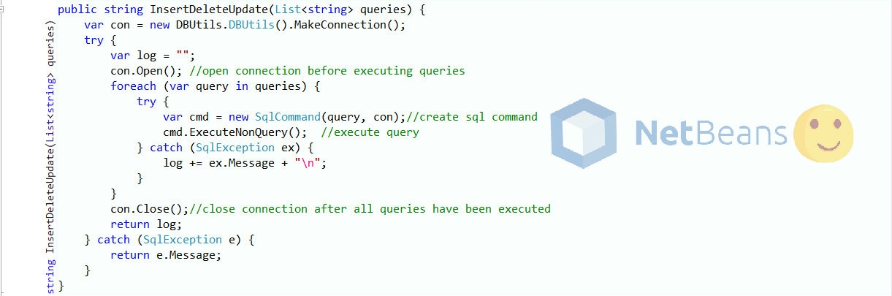

2.3 Mainform.cs

2.3.1 Main Form Shown: Initiate and bind the received list into Datagridview, then set value to text boxes.

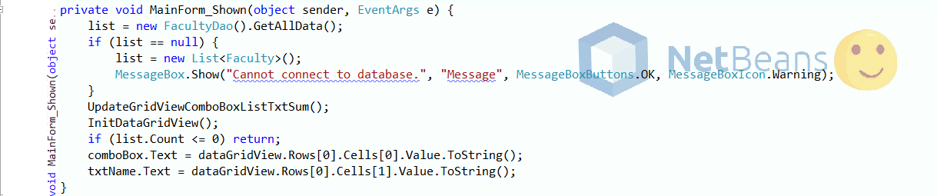

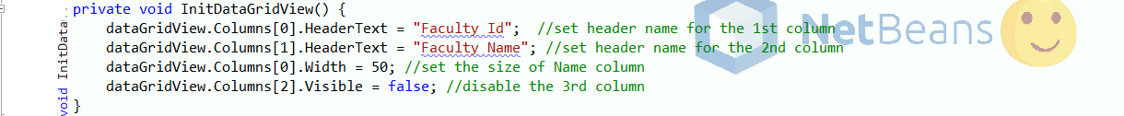

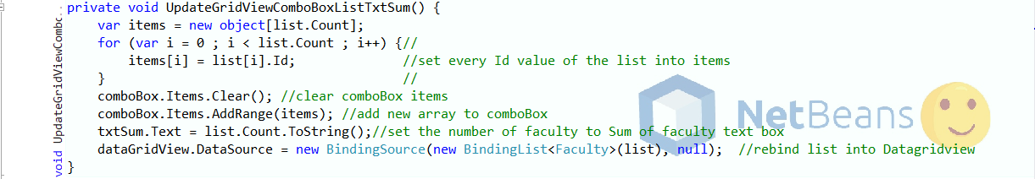

2.4 Add button function: Add a new value into list, then rebind the list to Datagridview.

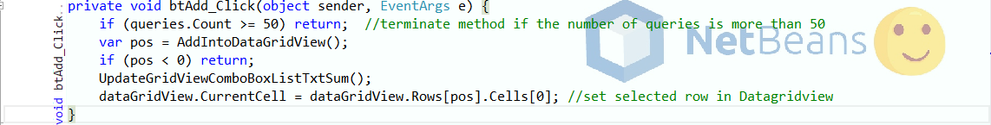

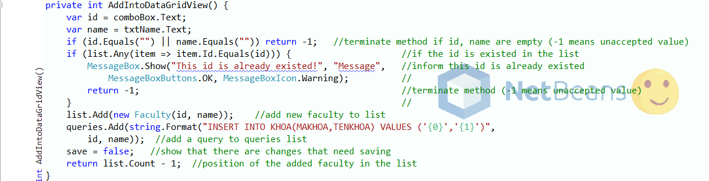

2.5 Edit button function: Edit a specific value in the list, then rebind the list to Datagridview.

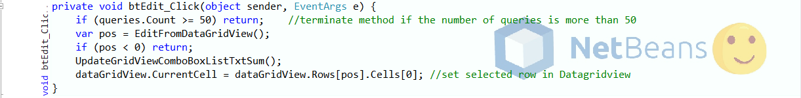

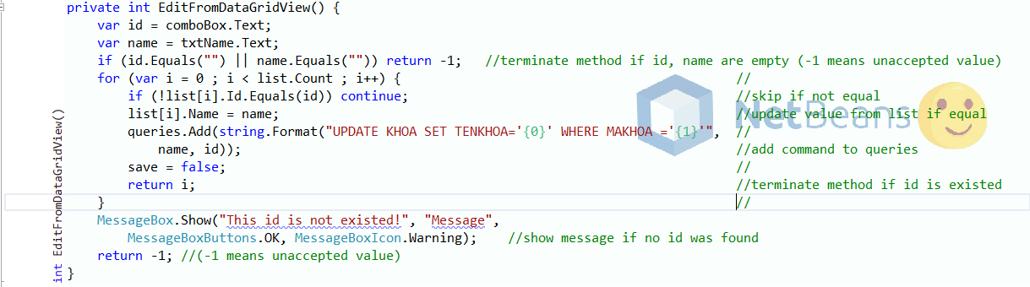

2.6 Delete button function: Delete a specific value in the list, then rebind the list to Datagridview.

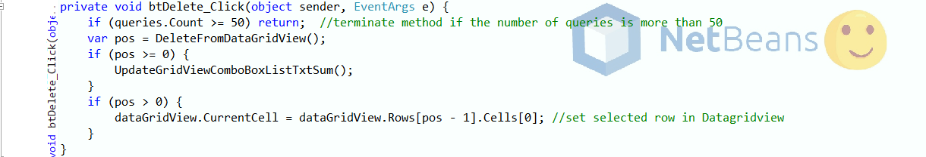

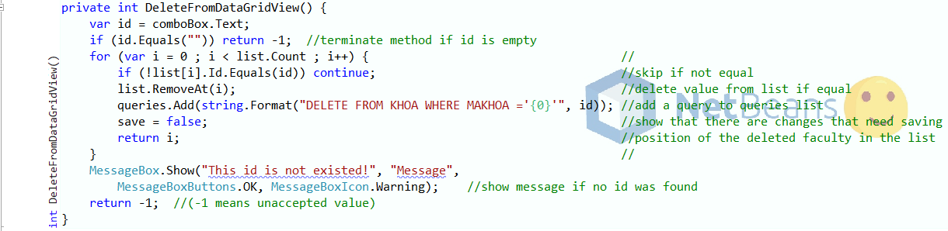

2.7 Save button function: Call GetAllData method (2.2.2), get list by calling InsertDeleteUpdate method (2.2.1). Rebind new list into Datagridview.

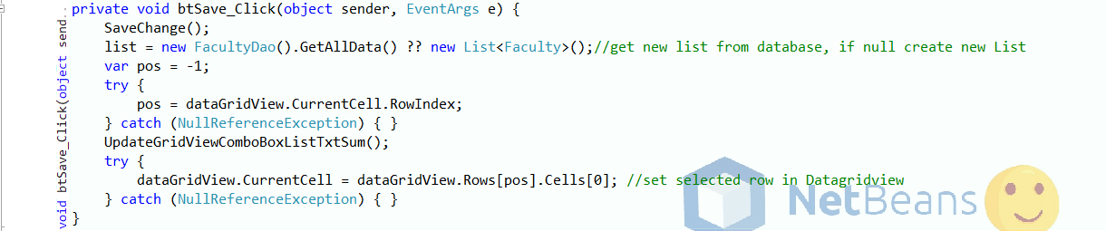

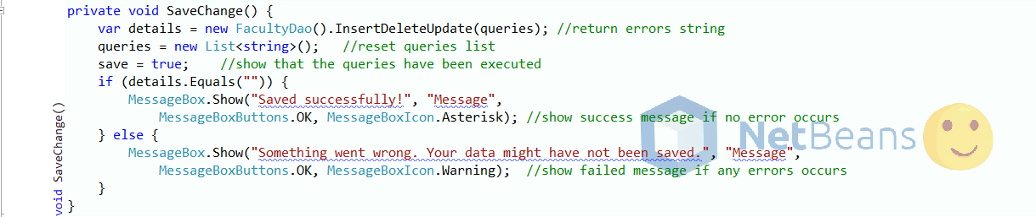

2.8 Clear button function: Clear all the text boxes.



2.9 Exit button function: Confirm save changes on exit.



